- From the i-twist Home screen choose Intake.
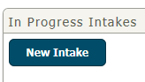
- From the Intake Landing Pages choose New Intake:
- This brings you to the Allegations and Concerns screen of the intake.
- Complete all information on the following screens and save:
  - Allegations and Concerns; and
  - Report Individuals.
- For status offender cases, do not complete the Victim/Perp Pairing screen:
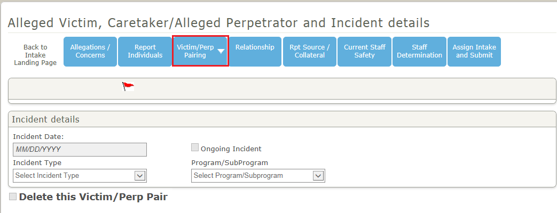

- Complete all information on the following screens and save:
  - Relationship;
  - Rpt Source/Collateral; and
  - Current Staff Safety.

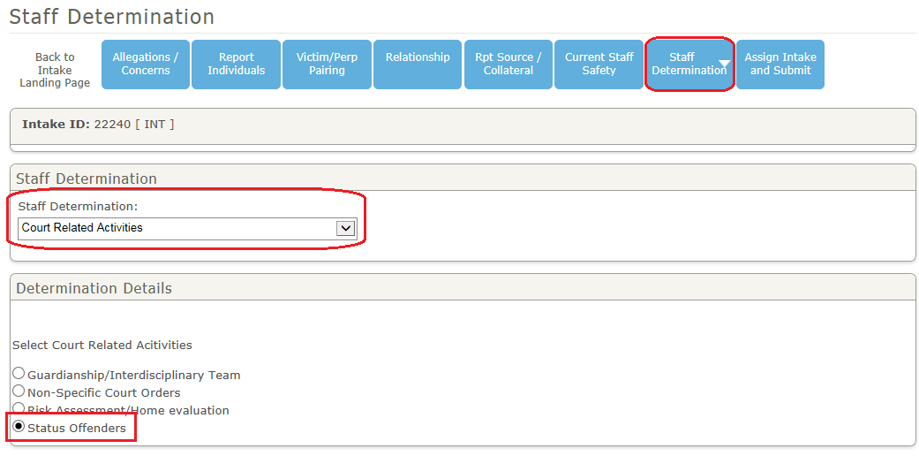
- On the Staff Determination screen, select Court Related Activities under the Staff Determination field; and choose Status Offenders under the Determination Details and save.

- Complete all information on the Assign Intake and Submit screen to submit the intake for FSOS approval.
